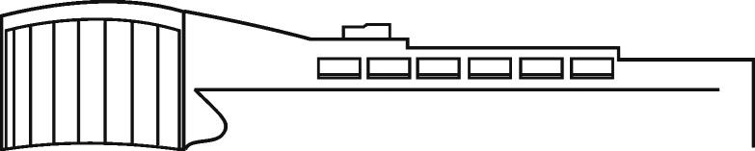
About the Applicant

Name: __________________________________________________________________________________

Birth Date (required): __ / __ / Norwich City School District Resident? Yes / No

Preferred contact method: e-mail / call / text Phone (Cell? Yes / No): ( )

Address: ________________________________________________________________________________

City: ___________________________ State: ________ Zip ____________ County: _________________

Email: _____________________________________________________Pin: _________________________
Required for electronic access, ebooks, streaming, etc.

Indicate any other last name by which you are or have been known: ________________________________
Card Application

page 1 of 2 Parent/Guardian
Office Use Only

Card Number: 10004________________________________________ Staff Initials: ___________________

Date: ______/______/_________ Circle one: Adult Young Adult Juvenile ID Checked?

I agree to obey all the rules and regulations of Guernsey Memorial Library, and to promptly pay all late charges and fines on my account for the injury or loss of library materials, and to give immediate notice of any changes in my name, address, e-mail address, and phone number.

Card Applicant Signature: __________________________________________________________________

Reference
(Adult friend or relative not living with you – in case we have trouble getting in touch with you.)

Name: __________________________________________________________________________________

Address: ________________________________________________________________________________

Email: ________________________________________________ Phone: ( )

I give my child permission to borrow materials from the library. I agree to be responsible for damage, loss, or fines incurred by my child. I understand that parents or guardians, not library staff, are responsible for materials selected and used by children.

Parent/Guardian Signature: _________________________________________________________________

Same as Page 1
Parent/Guardian Information
Required for card applicants under the age of 18.

Name: __________________________________________________________________________________

Address: ________________________________________________________________________________

City: ___________________________ State: ________ Zip ____________ County: _________________

Email: _____________________________________________________ Phone ( )

Indicate any other last name by which you are or have been known: ________________________________

page 2 of 2 Dalrymple 11/19

