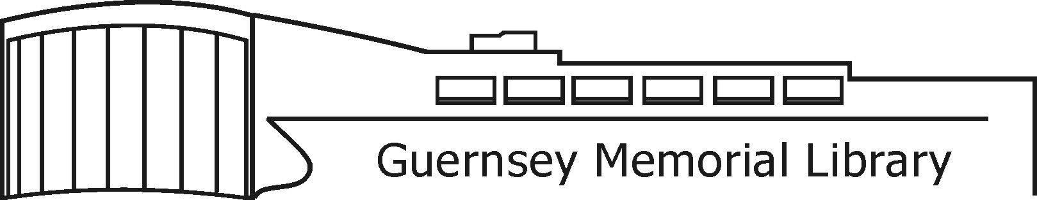

3 Court Street, Norwich, NY 13815 Phone (607) 334-4034 Fax (607) 336-3901 GuernseyMemorialLibrary.org

The Library Needs You!

Become a Guernsey Memorial Library Trustee!

Library trustees are powerful advocates for libraries. Through the coordination, hard work, and determination of trustees, new libraries have been built, budgets have been restored and increased, and new respect has been generated for the powerful role libraries play in communities. As part of a trustee board, trustees serve on a volunteer basis and are tasked with the duty of helping to direct the funds and policies of the institution. In general, the library board of trustees has a role in determining the mission of the library, setting the policy that governs the library, hiring and evaluating a library director, and overseeing the general management of the library.

To become a candidate for GML Trustee:

You must be at least 18 years of age and reside within the boundaries of the Norwich City School District.

Please submit a brief statement of qualifications and interest to the library director by April 28, 2021. Your statement will help voters to decide between candidates and will be posted around the library, on the library’s web and facebook pages, and in the Evening Sun.

Take a petition and obtain a minimum of 25 signatures of voters registered to vote in the Norwich City School District. Deliver your completed petition to Pam Salvati at the NCSD Office at 89 Midland Ave by 5 PM on April 28, 2021.

The drawing for ballot position will take place on April 29, 2021 at 8:30 AM promptly at the NCSD Office. You are not required to attend, but are welcome to do so. If you have any questions, call Pam Salvati at 334-2600 ext. 5506.

Best wishes in your journey to serve GML and the Norwich community!



