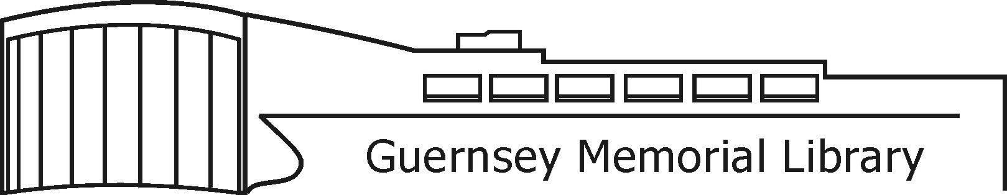

3 Court Street, Norwich, NY 13815 Phone (607) 334-4034 GuernseyMemorialLibrary.org

REQUEST FOR PROPOSALS

Guernsey Memorial Library

CAST IRON PIPE REPLACEMENT

February 19, 2025

Guernsey Memorial Library is seeking proposals from interested firms for the replacement of the building’s existing outflow cast iron piping. The building’s toilets see a heavy volume of use and there have been multiple overflow events which have been attributed to materials getting caught on the 50+ year old cast iron pipes and possibly a lack of sufficient pitch. We are also interested in proposals which might divide the system into more than one outflow so that if one branch of the plumbing is clogged, another branch might still be usable. This project will replace the main line and all of its branch lines with PVC and new hangers in the basement area.

A MANDATORY pre-bid meeting will be held onsite for contractors to look at the project, obtain any measurements, and ask questions. The MANDATORY pre-bid meeting will be held on Thursday March 13th at 2:00 PM.

*All sealed proposals shall be submitted to the library no later than March 28th by 6:00 p.m.*

It is anticipated that the proposals will be reviewed by Library Board at their monthly board meeting and an award made April 10th at 6:30 PM.

For questions regarding this RFP or to submit a proposal, please contact:

Connie Dalrymple

Guernsey Memorial Library

3 Court Street

Norwich NY 13815

guernsey@4cls.org