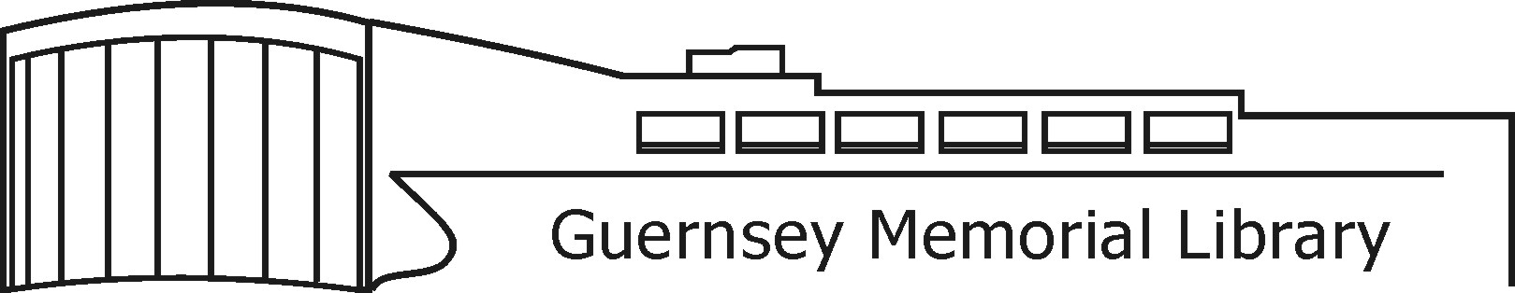
3 Court Street, Norwich, NY 13815 Phone (607) 334-4034 GuernseyMemorialLibrary.org

REQUEST FOR PROPOSALS
Guernsey Memorial Library
Elevator Sump Pump Installation

March 26, 2026

Guernsey Memorial Library is seeking proposals from interested firms for the installation of a sump pump in our elevator shaft. This is a mandatory prevailing wage job.
A MANDATORY pre-bid meeting will be held onsite for contractors to look at the project, obtain any measurements, and ask questions. The MANDATORY pre-bid meeting will be held on Tuesday April 7th at 10 AM.
All sealed proposals shall be submitted to the library no later than April 24, 2026 at 6 PM.

It is anticipated that the proposals will be reviewed by Library Board at their monthly board meeting and an award made May 14th at 5 PM.

For questions regarding this RFP or to submit a proposal, please contact:
Connie Dalrymple
Guernsey Memorial Library
3 Court Street
Norwich NY 13815
guernsey@4cls.org

