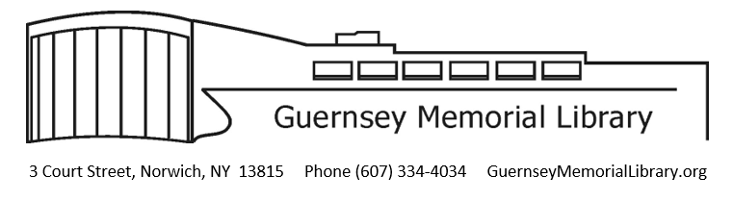

March 27, 2026

Dear Website Design/Hosting Firm Representative:

Please accept this letter as a Request for Proposals for the performance of services by a professional website design firm to redesign, host, and maintain Guernsey Memorial Library’s website.

Our current website can be found at https://GuernseyMemorialLibrary.org. The new design should address the following:

- A simple, eyecatching, and easy-to-use design. The library likes https://library.camden.nsw.gov.au/ as an example.
- A search box at the top of the page with a drop-down menu to select searching the catalog or the website itself. Here’s an example: https://services.slcpl.org/
- An easy-to-use interface that library staff can use for simple updates to the sites once designed and implemented
- Quick turn-around on more complex changes that the firm can make
- Site must be fully WCAG compliant

Qualified firms that wish to be considered must submit the following materials together with any additional information which may be deemed to be useful:

- Outline of previous experience with similar projects.
- References associated with similar projects.
- Length of time estimated to complete the project from planning through completion.
- Cost of redesign
- Cost for ongoing site maintenance
- Cost for site hosting

All proposals are to be delivered to Guernsey Memorial Library in a sealed envelope clearly marked on the outside “Website Services Proposal.” All proposals must be submitted by 6 PM on April 24, 2026. Bids will be opened at the May 14 board meeting at 6:30 PM. If a successful firm is identified, they will be hired by the Board of Trustees. The successful firm will be expected to enter into a contract with the Library and the proposal price must be in effect for 180 days following receipt.

Thank you for considering being of service to Guernsey Memorial Library and the Norwich community. Questions can be directed to guernsey@4cls.org.

Sincerely,
Connie Dalrymple
GML Director

